**Implementing a stock assessment to Chilean Hake 1992-2020**

# Background

Develop and stock assessment to Chilean hake incorporating and approximation by fleets. A great problem in the assessment is the presence of not declared catches related to under-report, bycatch and robbery. The National Fishery Service (“Servicio Nacional de Pesca”) is in charge of the statistical record of fishing, however only generate official landing without correction. The corrected landing series come from different research projects from university, scientific committee and management group, each of these data series present a different methodology and temporal extension (Table 1). The corrected landing between 1992-2001 comes from the management group, while the corrected landing from 2002 until the present year comes from the scientific group.

**Table 1**. Time series of landing to stock assessment (1992-2020) in industrial fleet (Ind) and artisanal fleet (art). Official landing report (decla) and not official (ndecla).

|  |  |  |  |  |  |  |
| --- | --- | --- | --- | --- | --- | --- |
| **year** | **Ind_decla** | **art_decla** | **Ind_ndecla** | **art_ndecla** | **Total_ind** | **Total_art** |
| 1992 | 54324 | 8320 | 3784 | 24000 | 58108 | 32320 |
| 1993 | 51654 | 12608 | 16745 | 25436 | 68399 | 38044 |
| 1994 | 54620 | 13487 | 17242 | 26484 | 71862 | 39971 |
| 1995 | 58832 | 16571 | 17593 | 25937 | 76425 | 42508 |
| 1996 | 64721 | 27403 | 10136 | 14233 | 74857 | 41636 |
| 1997 | 69035 | 18585 | 9011 | 24825 | 78046 | 43410 |
| 1998 | 68532 | 11619 | 17746 | 36370 | 86278 | 47989 |
| 1999 | 76042 | 27747 | 12051 | 21252 | 88093 | 48999 |
| 2000 | 82397 | 27746 | 12448 | 25008 | 94845 | 52754 |
| 2001 | 88979 | 32221 | 3565 | 19253 | 92544 | 51474 |
| 2002 | 89222 | 26818 | 19533 | 33673 | 108755 | 60491 |
| 2003 | 89592 | 25751 | 18544 | 28908 | 108136 | 54659 |
| 2004 | 57345 | 16253 | 23098 | 4603 | 80443 | 20856 |
| 2005 | 47436 | 4580 | 6054 | 2821 | 53490 | 7401 |
| 2006 | 47958 | 4273 | 4726 | 2507 | 52684 | 6780 |
| 2007 | 39681 | 6167 | 5463 | 5748 | 45144 | 11915 |
| 2008 | 35144 | 12812 | 6712 | 6062 | 41856 | 18874 |
| 2009 | 33524 | 13620 | 2673 | 16618 | 36197 | 30238 |
| 2010 | 33801 | 15396 | 5274 | 6478 | 39075 | 21874 |
| 2011 | 28747 | 16858 | 3070 | 9109 | 31817 | 25967 |
| 2012 | 25360 | 14269 | 5435 | 8977 | 30795 | 23246 |
| 2013 | 23618 | 13309 | 5488 | 10672 | 29106 | 23981 |
| 2014 | 10889 | 7684 | 2392 | 10579 | 13281 | 18263 |
| 2015 | 11638 | 7771 | 1084 | 16543 | 12722 | 24314 |
| 2016 | 13453 | 7456 | 1687 | 14347 | 15140 | 21803 |
| 2017 | 13654 | 7778 | 1512 | 18278 | 15166 | 26056 |
| 2018 | 13833 | 8290 | 1341 | 23133 | 15174 | 31423 |
| 2019 | 17648 | 8333 | 746 | 22143 | 18394 | 30476 |
| 2020 | 13831 | 5021 | 585 | 13341 | 14416 | 18362 |

# Objective

Propose and develop a robust stock assessment to Chilean hake, considering the effects of not declared catches product of the increase of these in recent years.

# Management system

The fishery management system in Chile includes the fishing authority represented by the Ministry of Economy (ME), the SF and the National Fisheries Service (NFS; Servicio Nacional de Pesca). The ME and SF are representatives of the government, while the NFS is in charge of the statistical record of fishing and aquaculture, as well as the compliance of fishing regulations. Until 2012, the decision system, according to the Chilean General Law of Fishing and Aquaculture, established that the SF should propose an annual TAC to be approved or rejected by the National Fishery Council. From 2013, this management system was modified, with a change in the role of the Scientific Committee, which in the current system establishes a range for the annual TAC.

# Stock assessment to management

The general stock assessment of *M. gayi gayi* applies an approach based on a statistical catch-at-age-model method that considers a single stock unit, combined sexes, constant natural mortality (*M*= 0.35 per year) for ages 2 to 12. Furthermore, by the year 2010, this model was reformulated to incorporate additional mortality caused by jumbo squid (*D. gigas*) predation. Stock assessment by fleet (artisanal and industrial) was presented in the scientific commit in 2015, however similar results in population indicators the management follow based on a model that does not consider difference by fleet mainly by simplicity and faster access to age-structured information (age key and age composition).

# Consideration to update the stock assessment

A factor that we consider relevant in incorporate a stock assessment by fleets, is the increase in the not-reported landing, especially by a fraction of vessels with technic characteristics similar to the artisanal fleet. However, at the moment dos not exist structured information of the not-reported landing.

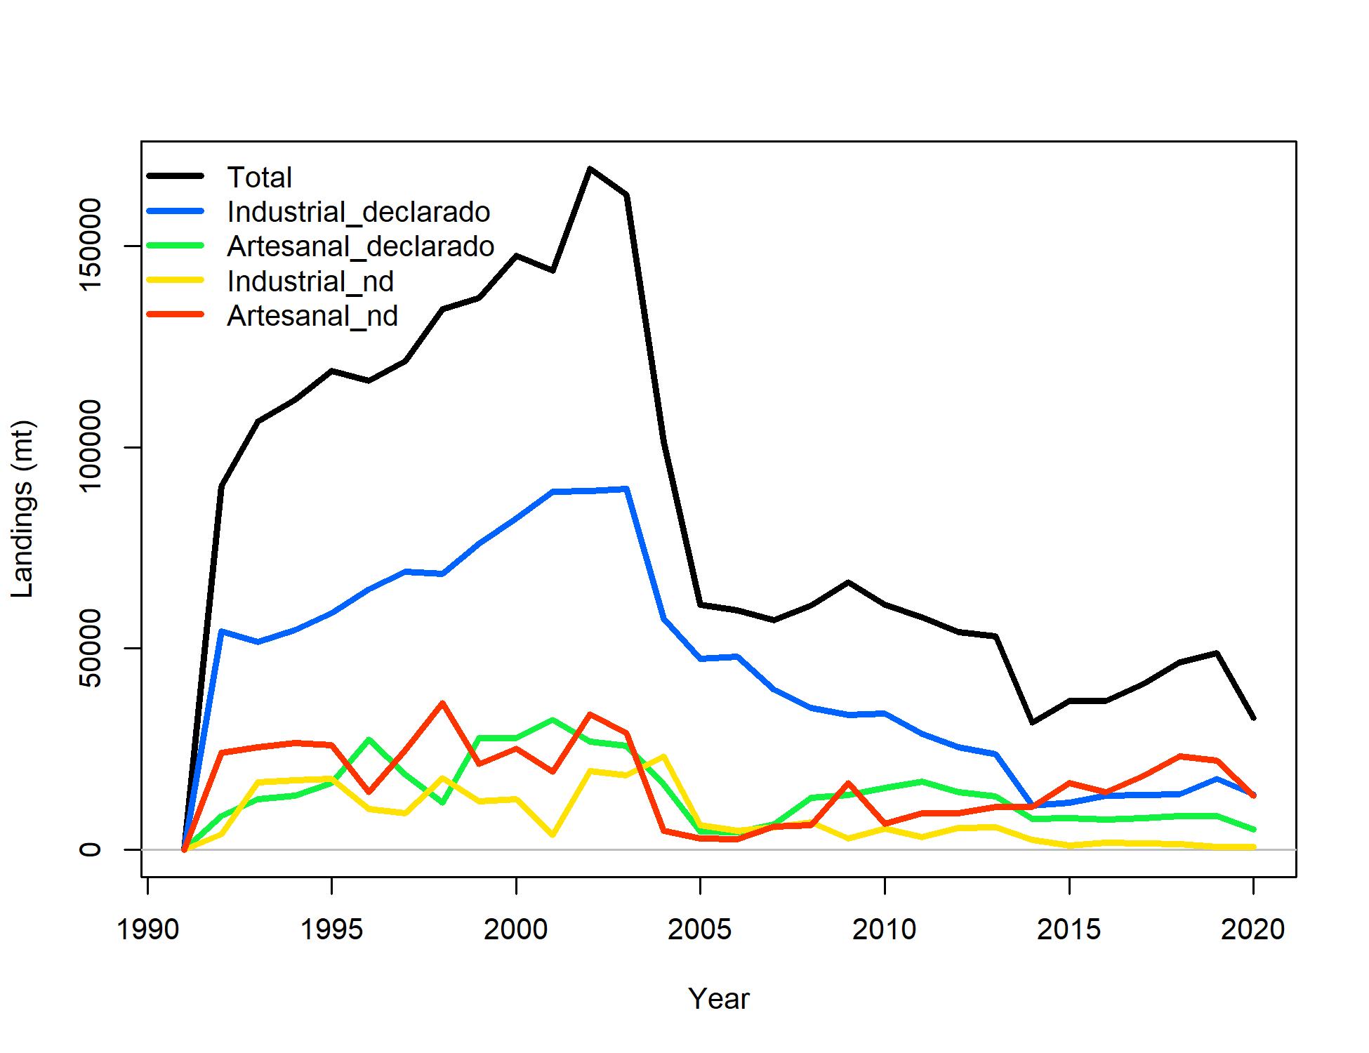

**Figure 1. Landing by fleet industrial and artisanal declared (official) and not declared between 1992-2020.**

# Alternative approach

In different demersal and pelagic fisheries in Chile to analyze the effect of not-declared catches. The approach is to develop an assessment with the official landing and others in the same condition with the correcting the landing and analyze the difference in a different indicator like; spawning biomass, recruitment, fishing mortality etc. In summary, correspond to a sensibility in the landing levels and comparison of indicators results.

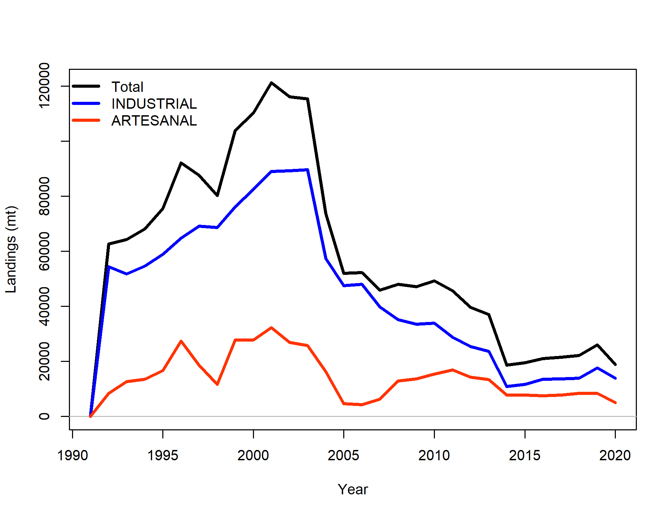

**Figure 2. Landing by fleet industrial and artisanal declared (official) between 1992-2020.**

# Stock assessment analysis

To develop a robust stock assessment for Chilean hake, a series of different models were developed, associated with the possibilities to generate approaches to compare performance between models and have some support in the approach to incorporate and analyse the effect of not-declared catches on the population.

## Models description

The models present different configurations associated with the approach to incorporate fleets and reported and not reported catches.

F= fleet

CO= landing corrected (declared + not-declared)

OF= landing declared

M= constant natural mortality

L = Lorenzens natural mortality

**m1 = 2FCOM (2 fleets + landing correction + M cte)**

**m2 = 2FOFL (2 fleets + landing official + M variable)**

**m3 = 2FOFM (2 fleets + landing official + M cte)**

**m4 = 4FSDM (4 fleets + M cte)**

**m5 = 4FSDL (4 fleet + M variable)**

The approach called 4 fleets, considers the fraction of the artisanal and industrial fleets not reported as fleets for modelling purposes. In this way is possible to incorporate the not-declared catches in a modelling framework that allow estimation of mortality associated with not-declared exploitation.

**Github site**

In the github site <https://github.com/claugatic/hakech>. Were stayed the data and models setting to Chilean hake implemented in this step.